ILP Project Plan:

Improving and Increasing Knowledge of The Unreal Engine

# Project Overview:

For the independent learning plan, I have been asked to further develop a certain skill within game development, I have chosen to broaden my knowledge of unreal engine game development. I will learn and showcase different aspect of development within the unreal engine, the techniques I want to explore are as followed

* Audio Implementation
* Visual effects
* Cinematic Cutscenes
* Lighting

I will present this project in a single unreal scene and will include the aspects above.

# Reasoning

The reasoning behind this project is because my primary engine for the last 3 years of my undergrad course was Unity, to increase my employability I want to add an additional engine to my catalogue of knowledge and additional work to add to my portfolio.

# Standards:

The standards of each technique are as followed;

Audio Implementation:

The aspects of audio I will be exploring will be implementing ambient and environmental sound effects and game music. I will demonstrate different types of attenuation shapes and how they affect the way the sound is heard. I will also be exploring reverb effect and how they can craft the overall feel of the environment the player is in.

Visual Effects:

The aspect of visual effect I will be exploring and demonstrating will be creating and editing different particle effects using the cascade tool within the particle system. From my research I have noticed similarities between the effects used within the games and other projects (Appendix B) these similarities include;

* Main body effect
* Additional effect on the edges, small sparks, fire embers, smoke
* Most effects are linear; however, some have noise in other directions
* Self-Illumination is used in most effects

I will also explore how to optimize these effects, so they don’t hinder performance.

Cinematic Cutscenes:

I will create and demonstrate a short cinematic cutscene using multiple camera’s, I will cycle through these cameras to give different perspective on the scene. I will also add a few skeletal meshes and add animation tracks to them. I will be using the sequencer tool within unreal to create the cutscene.

Lighting:

I will demonstrate lighting a scene depending on the environment

# Management Technique:

To achieve these goals, I will be working on the project for 8 – 16 hours a week. I will be using the agile management style as it gives me the freedom to go back during development and change aspect of the project, I will be using Trello to set and track tasks.

Risk Assessment

Work breakdown

# Appendix

# Appendix A

# Outline the steps/plan for your project:

|  |  |  |
| --- | --- | --- |
| **Project Milestones** | | |
| **2018-2019** | **Week #** | **Milestone Deliverables and Tasks** |
| 14/11/18 – 21/11/18 | Week 1 |  |
| 21/11/18 – 28/11/18 | Week 2 |  |
| 28/11/18 – 5/11/18 | Week 3 |  |
| 5/12/18 – 12/12/18 | Week 4 |  |
| 12/12/18 – 19/12/18 | Week 5 |  |
| 19/12/18 – 26/12/18 | Week 6 |  |
| 26/12/18 – 2/1/19 | Week 7 |  |
| 2/1/19 – 9/1/19 | Week 8 |  |
| 9/1/19 – 16/1/19 | Week 9 |  |
| 16/1/19 – 23/1/19 | Week 10 |  |
| 23/1/19 – 30/1/19 | Week 11 |  |
| 30/1/19 – 6/2/19 | Week 12 |  |
| 6/2/19 – 13/2/19 | Week 13 |  |
| 13/2/19 – 20/2/19 | Week 14 |  |
| 20/2/19 – 27/2/19 | Week 15 |  |
| 27/2/19 – 6/3/19 | Week 16 |  |
| 6/3/19 – 13/3/19 | Week 17 |  |
| 13/3/19 – 20/3/19 | Week 18 |  |
| 20/3/19 – 27/3/19 | Week 19 |  |
| 27/3/19 – 3/4/19 | Week 20 |  |
| 3/4/19 – 10/4/19 | Week 21 |  |
| 10/4/19 – 17/4/19 | Week 22 |  |
| 17/4/19 – 24/4/19 | Week 23 |  |
| 24/4/19 – 1/5/19 | Week 24 |  |
| 1/5/19 – 8/5/19 | Week 25 |  |
| 8/5/19 – 15/5/19 | Week 26 |  |
| 15/5/19 – 22/5/19 | Week 27 |  |
| 22/5/19 – 29/5/19 | Week 28 |  |
| 29/5/19 – 5/6/19 | Week 29 |  |
| 5/6/19 – 12/6/19 | Week 30 |  |
| 12/6/19 – 19/6/19 | Week 31 |  |
| 19/6/19 – 26/6/19 | Week 32 |  |
| 26/6/19 – 3/7/19 | Week 33 |  |
| 3/7/19 – 10/7/19 | Week 34 |  |
| 10/7/19 – 17/7/19 | Week 35 |  |

# Appendix B

Particle effect MoodBoard

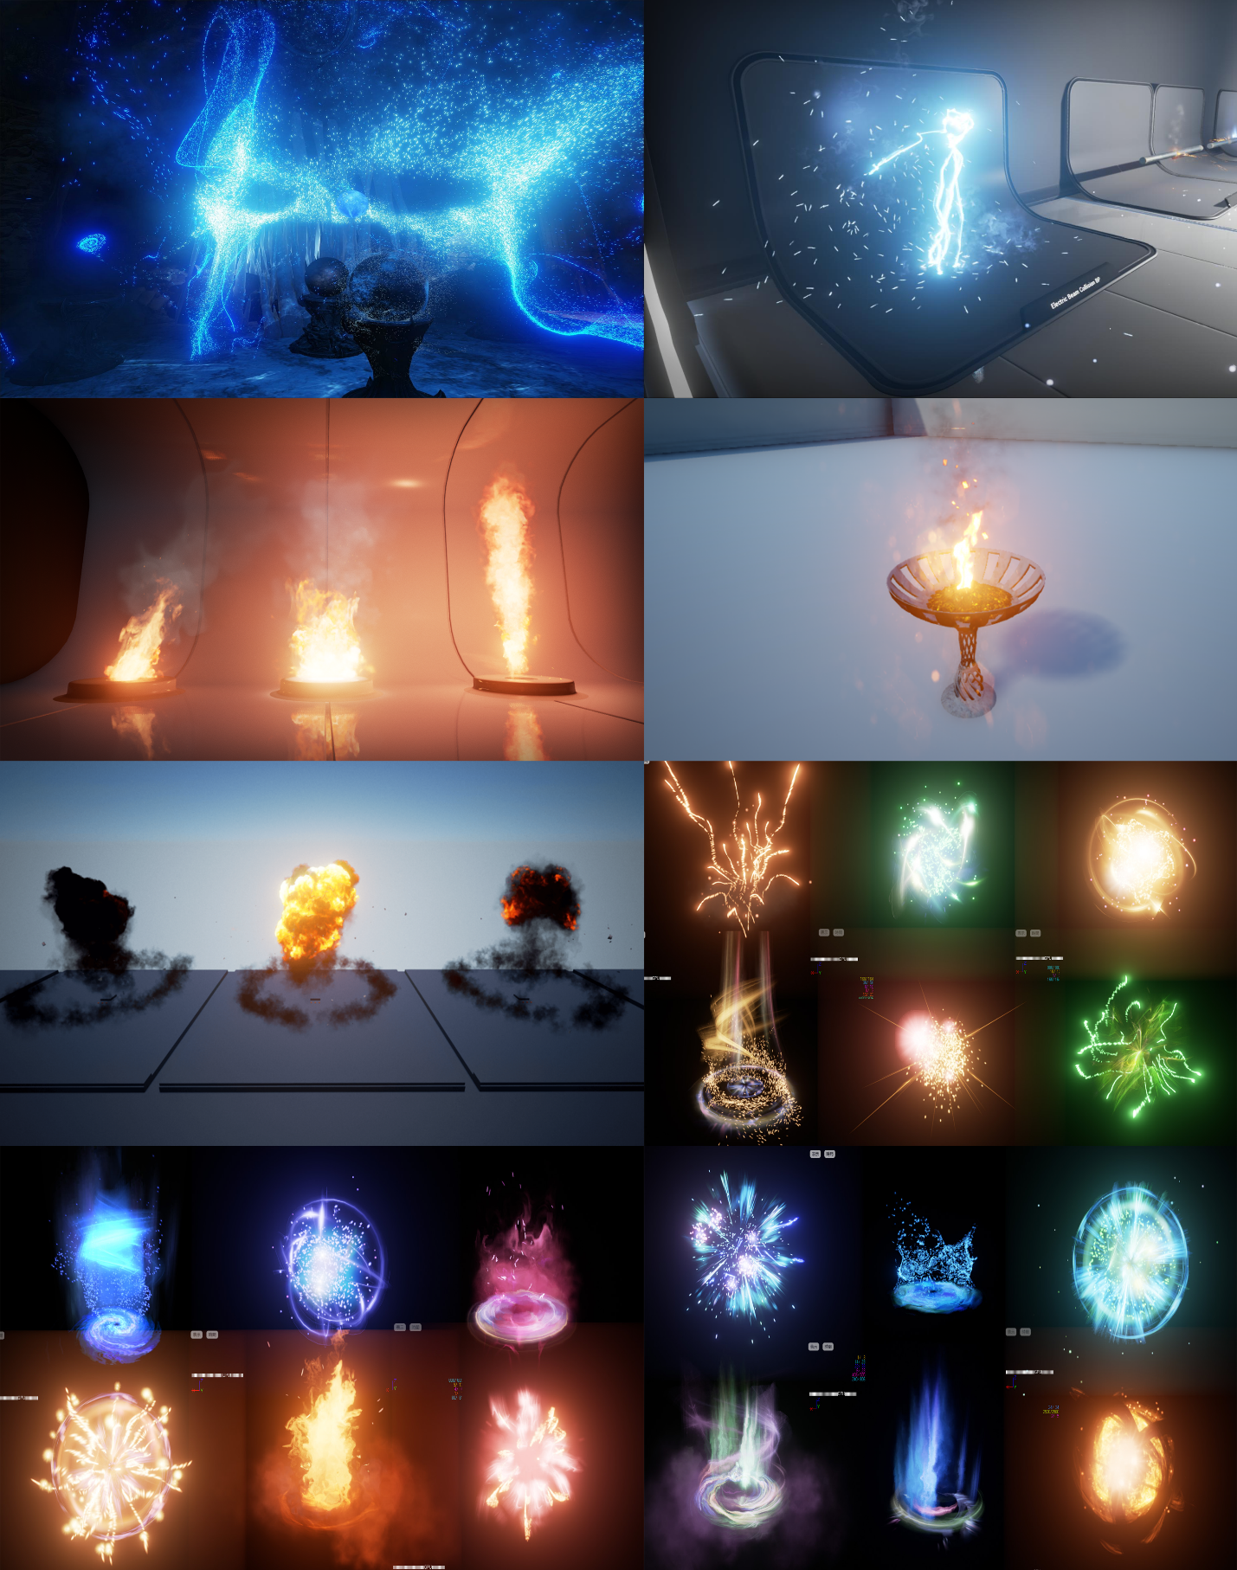

# Appendix C

Sequencer MoodBoard

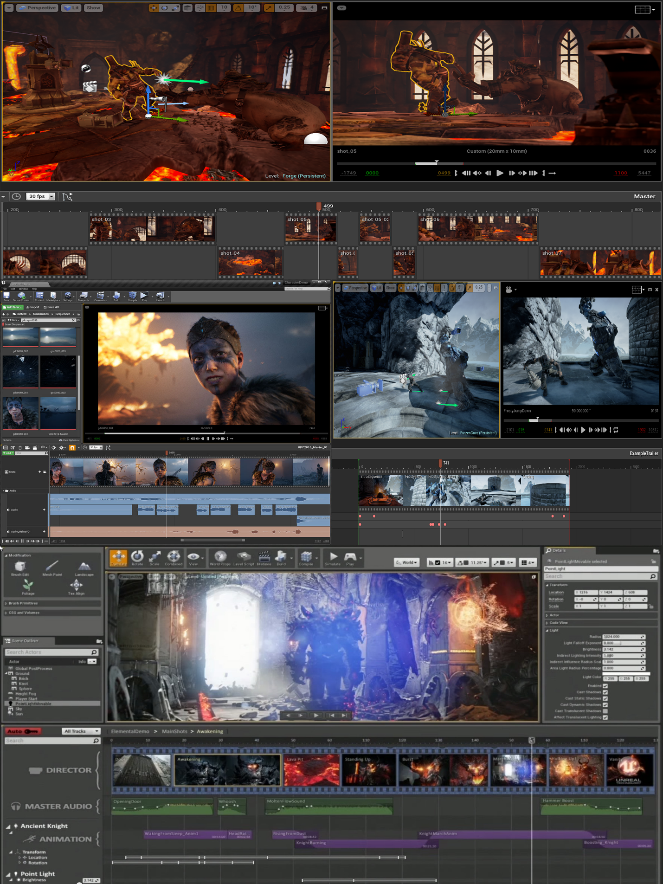

# Appendix D

Lighting the scene

